**UNIT 2 DESCRIBING PEOPLE**

**PART ONE WARMING UP**

**⮊Task 1: Look at the following picture. Supply the vocabulary to form the image.**

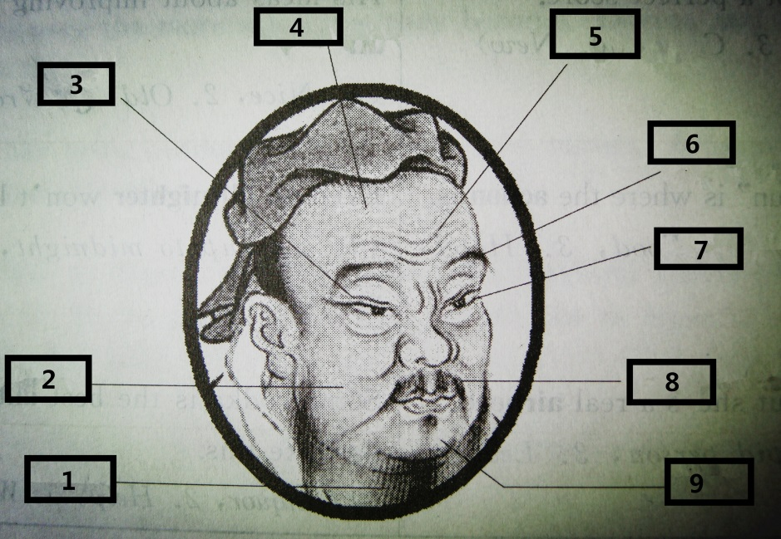

1）____beard_______

2）____cheek____

3）____eyelid____

4）____forehead___

5）____wrinkles____

6）____eyebrow____

7）____eyelashes___

8）____moustache__

9）____chin ____

**PART TWO**

**Text 1**

**Pictures from my trip back home**

**Key**

fair dark dark

heart-shaped thin bushy

wavy

cute curly adorable

**Text 2**

**iGenius – How Steve Jobs changed the world** *

**⮊Task 1: Watch the video named “iGenius – How Steve Jobs changed the world” and complete the facts of Steve Jobs.**

**Achievements:**

* Changed people’s lives with products such as __the PC_______, _the iPod__, _the iPhone_, and _the iPad_.
* Called the iGenius for making complicated things _simple_ and _beautiful_.

**Early years:**

* Born in __1955__.
* Adopted by a working-class couple in California’s _Silicon Valley_.
* Went to Oregon in __1972__ and attended a college.
* Liked the music of the Beatles and Bob Dylan, took drugs and went to _India__.
* Returned to California in __1975_.

**Apple I:**

* Joint effort of Steve Jobs and Steve Wozniak.
* Had no _power supply_ or __casing_, just a beginning.

**Apple Computer Inc:**

* Formed with the help of an _investor_.

**Apple II:**

* A great improvement of Apple I.
* Faster, had _ text display _, color graphics and _ plastic casing_.
* The reinvention of _the mouse_ was a huge success.
* Good sales brought Apple Company to go public in __1980_ and made Steve Jobs worthy of $_200 million__ at the age of ___25__.

**⮊Task 2: Listen to the recording and take notes of the words used to describe Steve Jobs.**

had a vision, demanding perfection, could rip into people, tough to work for, genius, difficult, tough, dictatorial, with a very clear sense of his instinct, abrasive, brash, thought he knew everything, “the guy”…

**PART THREE SPEAKING**

**⮊Task 1: Watch the music video “You belong with me” and fill in the blanks.**

1. humor
2. short skirts
3. easy
4. high heels
5. laugh
6. dreams

**PART FOUR LONG CONVERSATION BOX**

**⮊Task 1: Listen and answer the questions you have just heard.**

**Key**

8. D 9. B 10. B 11. C

**⮊Task 2: Listen and answer the questions you have just heard.**

**Key**

C D C C

**PART FIVE HOMEWORK**

**⮊Task 1: Listen to the short biographies and complete the table below.**

|  |  |  |  |  |
| --- | --- | --- | --- | --- |
| Name | Nationality | Birth | Death | Achievements |
| Albert Einstein  (physicist) | American | March 14, 1879 | 1955 | the 1921 Nobel Prize in Physics  the creator of the theory of relativity |
| Wolfgang A. Mozart  (composer) | Austrian | 1756 | 1791 | 41 41 symphonies, 27 piano concertos, 23 string quartets, 17 piano sonatas, 7 major operas, and numerous works for voice and other instruments |
| William Shakespeare  (playwright and poet) | English | 1564 | 1616 | His works include poetry, comedies and tragedies |